Table of Contents:

1. Start Button……………………………………………...……..2
2. Dashboard………………………………………………….......3
3. Query Student Data Button……………………………….…....3
4. Import Student Data Button………………………………........4
5. Read Final Grades Button……………………………...……....4
6. Add Student Button………………………………………...…..5
7. Students in Waterloo Button…………………………………....6
8. Students in Toronto Button……………………………...……...7
9. Course Enrolments Button……………………………………...7
10. Course Failures Button………………………………………....8
11. Students from St. Jacobs Button………………………………..9
12. Grades Report(.docx) Button………………………………….10

**A)** When opening the project the user a Start button is displayed. From this start button a dashboard will appear from which the rest of the project’s features can be accessed.

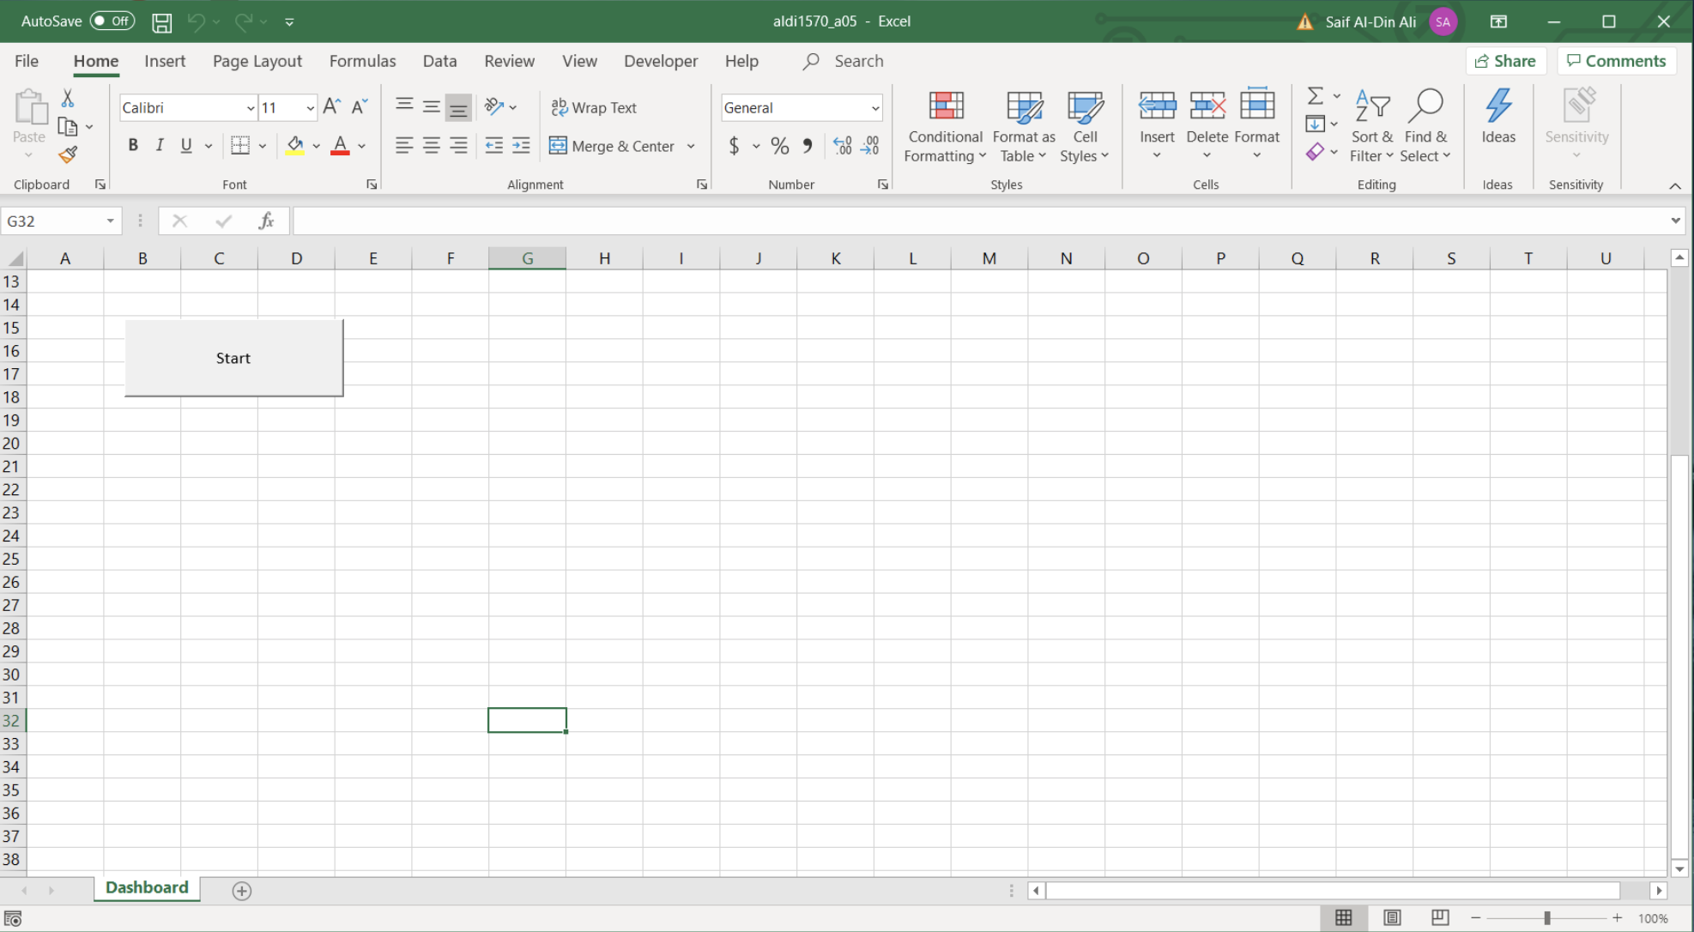

Immediately after clicking the Start button the user will be prompted with a dialog box where they can select the database the application will query. This application is built to use the tables in the Students202009.accdb database. Once the user selects their database the application will create a connection to it accessible to all other features, buttons and forms.

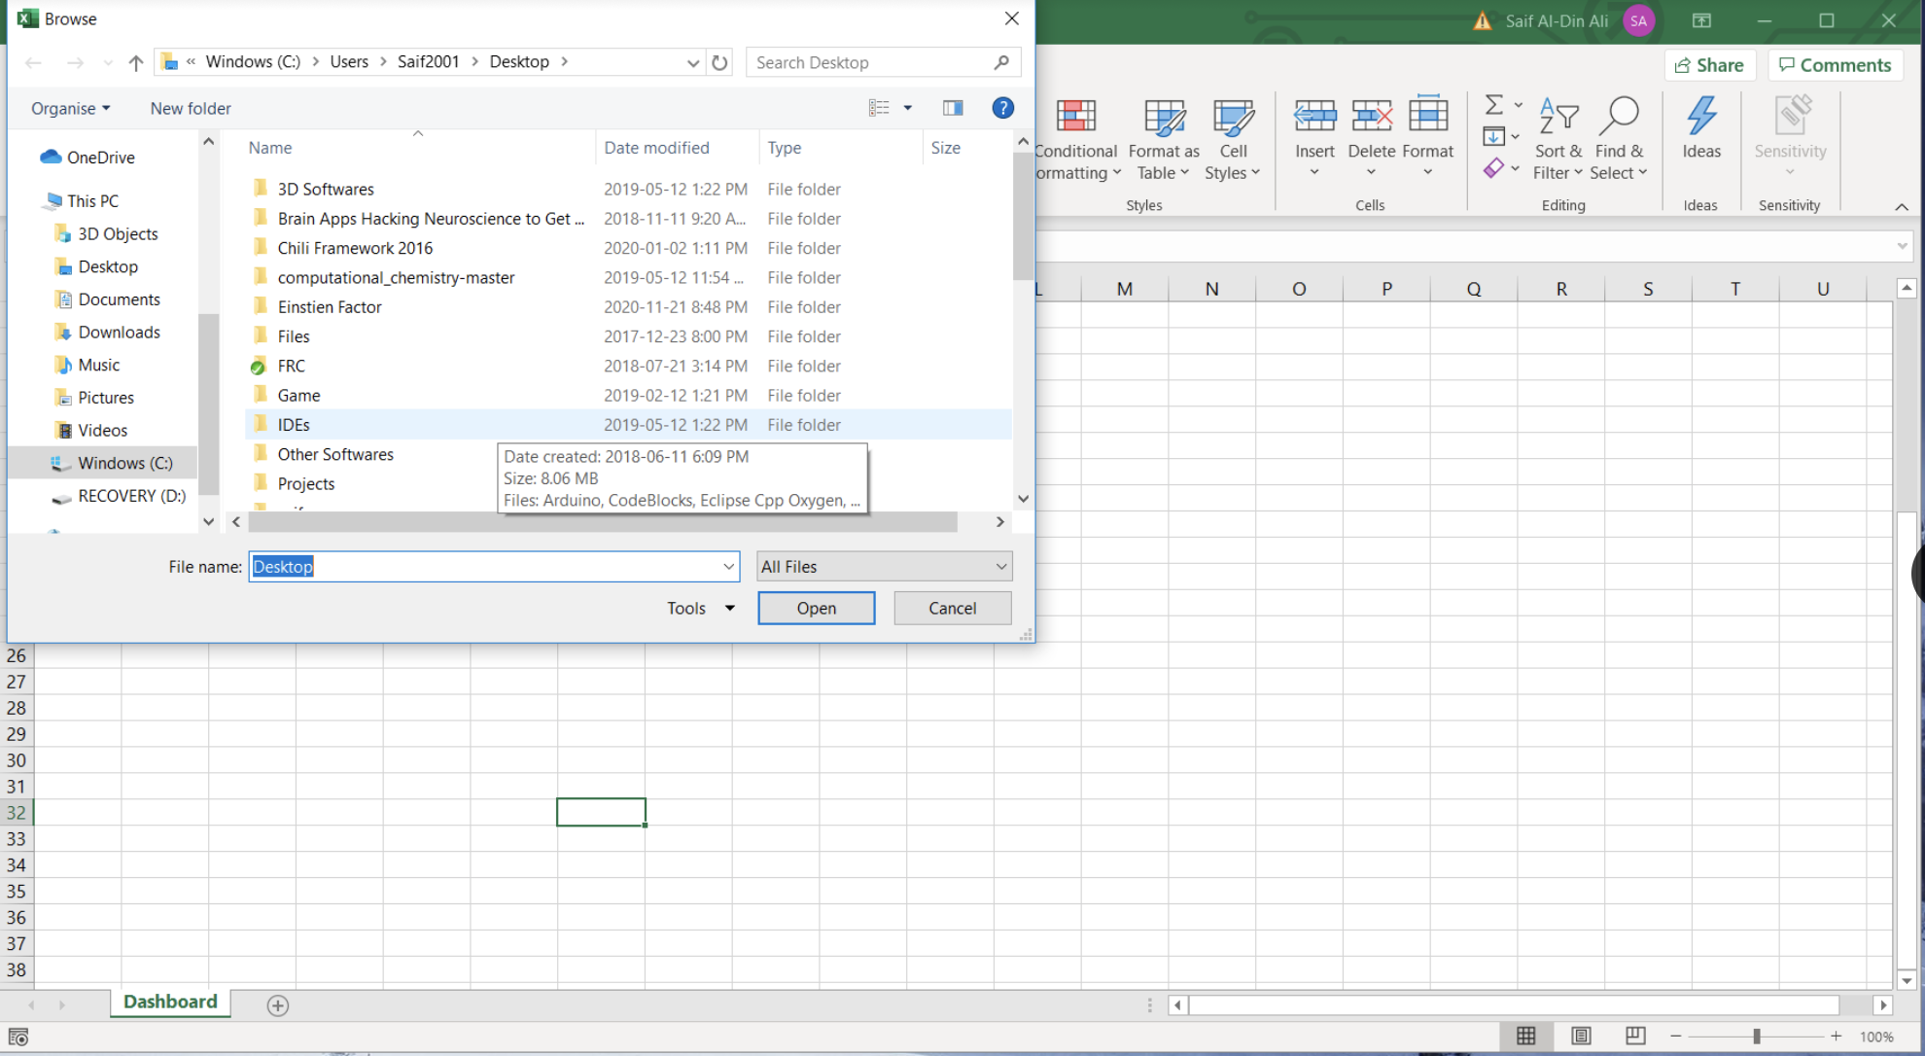

**B)** A dashboard will appear after the user selects their database. This dashboard will display all of the buttons that control the features of this application.

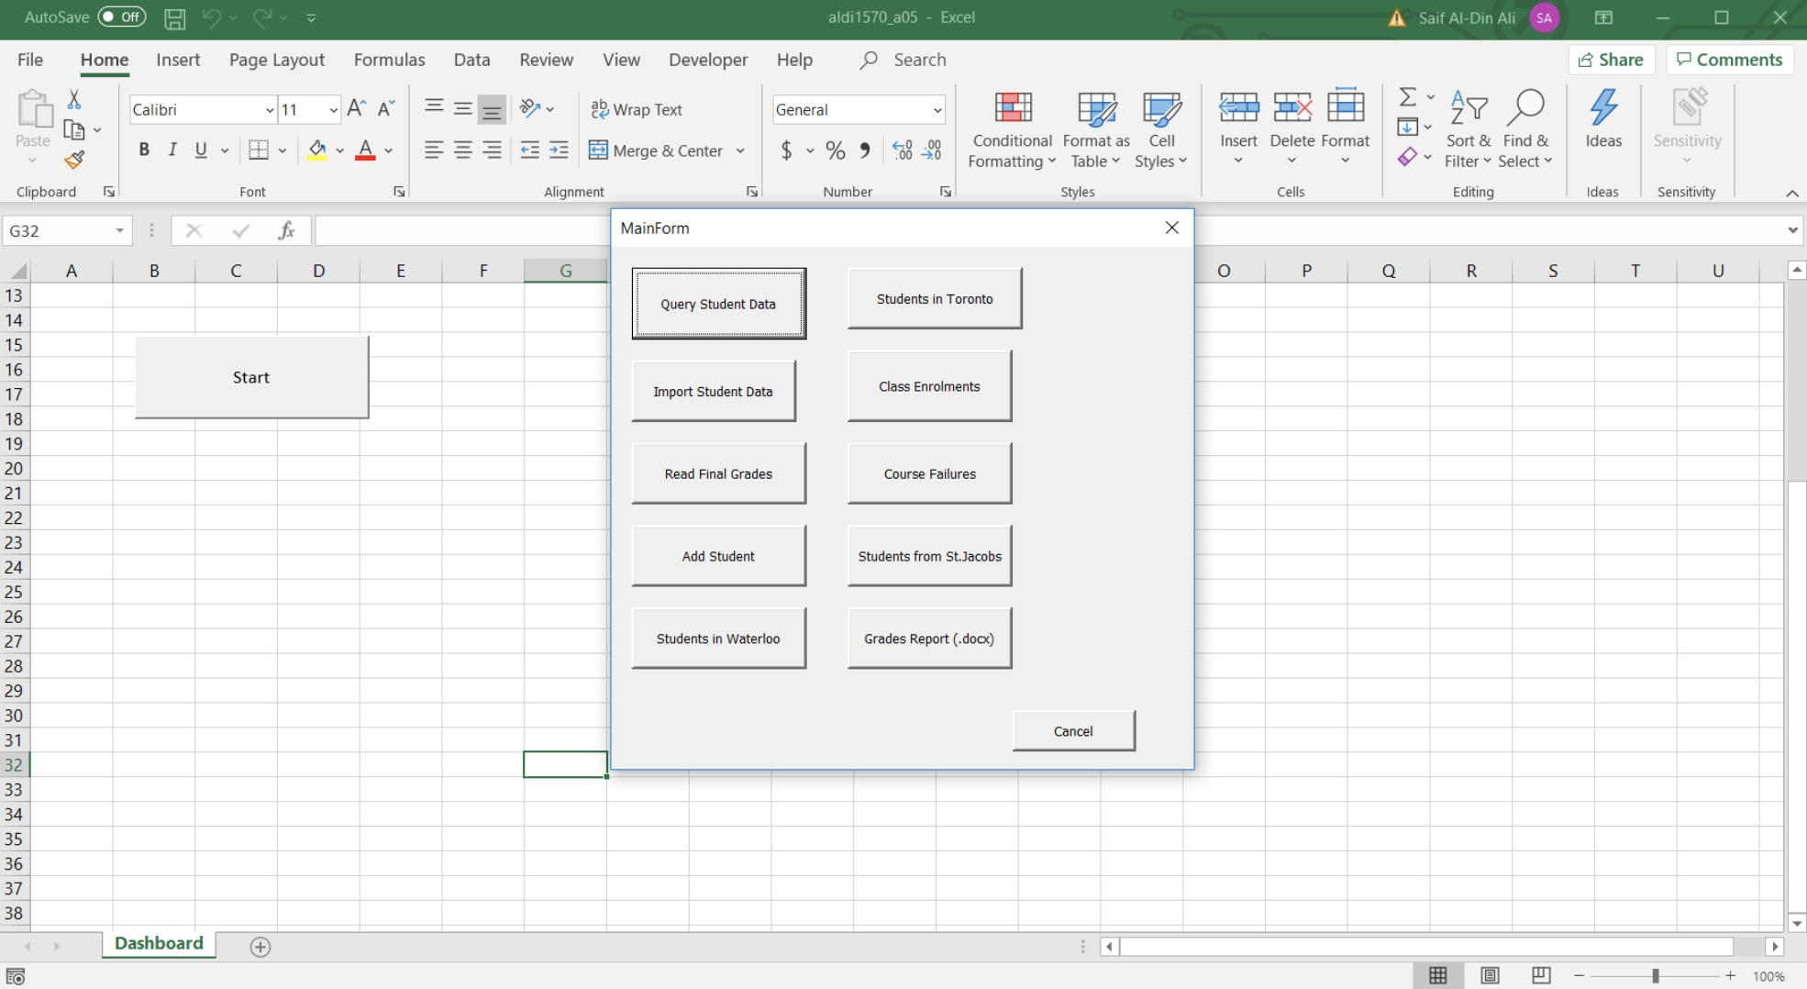

**C)** The first button ‘Query Student Data’ will query the database and retrieve information about the students. This information will be displayed in a new worksheet called ‘Student List’. The dashboard will close to allow the user to immediately see the results.

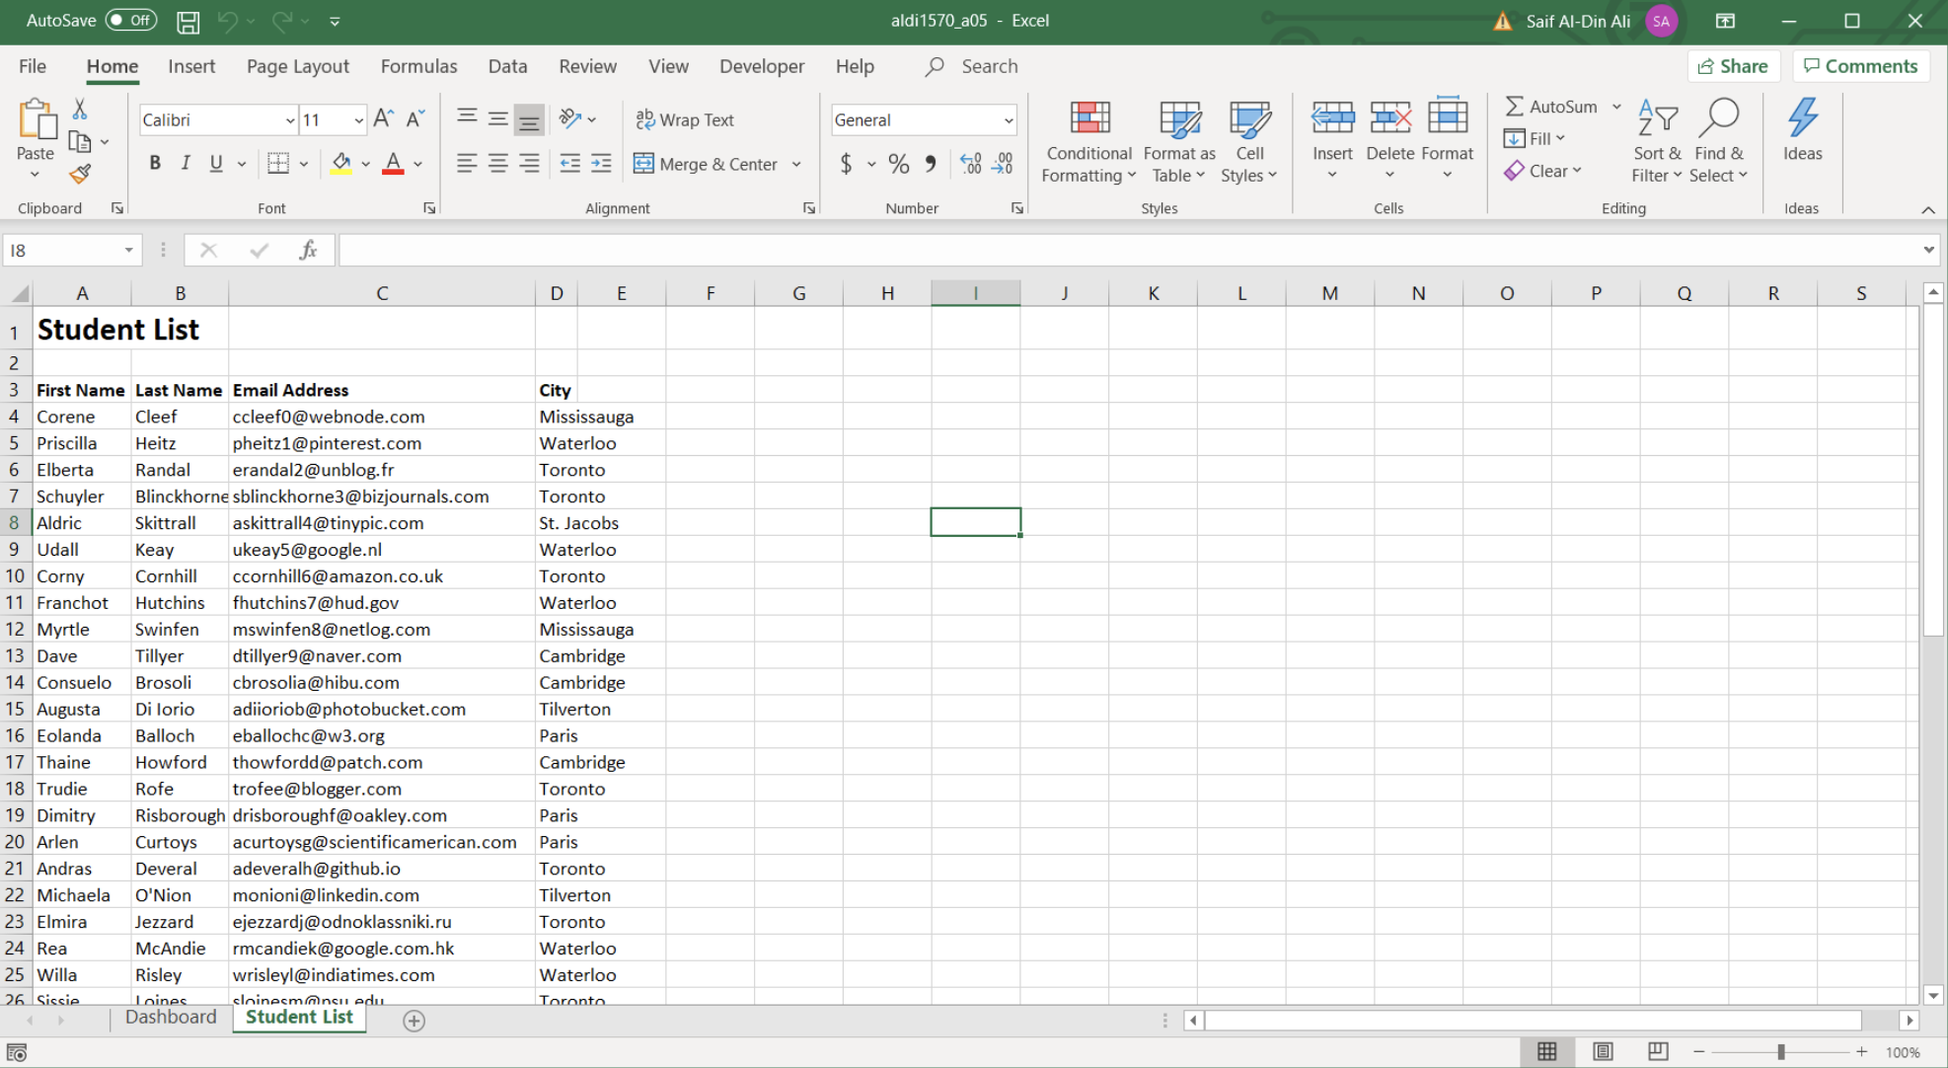

**D)** The second button ‘Import Student Data’ will open a dialog box where the user can select a file import.dat where the application will read the data and create a new worksheet ‘Import Students’ that displays information about the students from the .dat file.

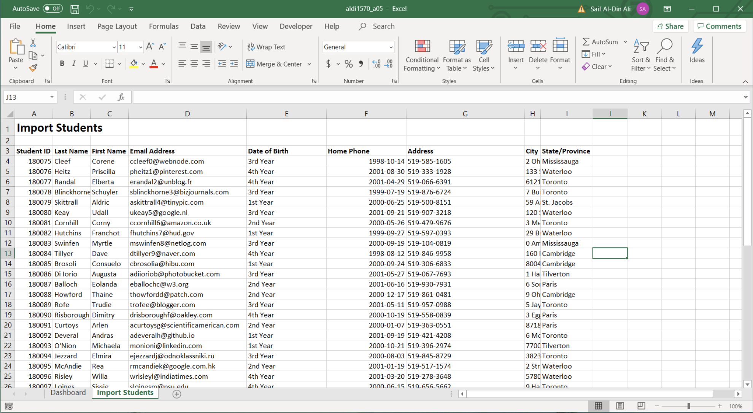

**E)** The third button ‘Read Final Grades’ will open a dialog box where the user can select the file finalgrades.dat. The application will then read the data and write it to the Access database as well as save it to an array. A message box will appear to alert the user when the process is complete.

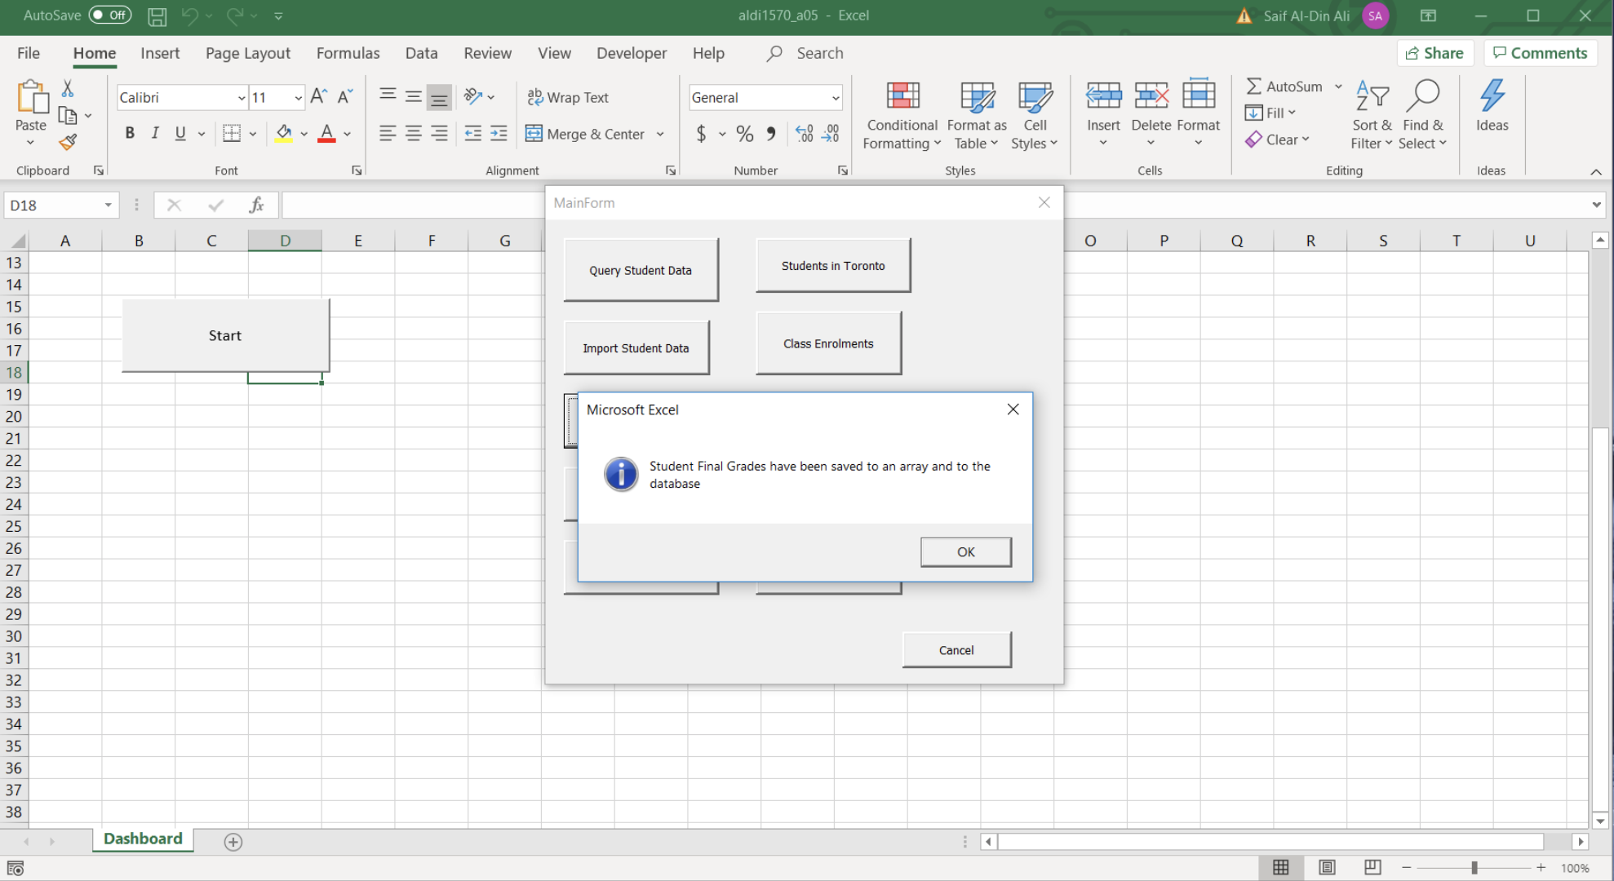

**F)** The fourth button ‘Add Student’ will display a userform where the user can add a new student. The user will not be able to add a StudentID as it will be randomly generated between 20000 - 30000.

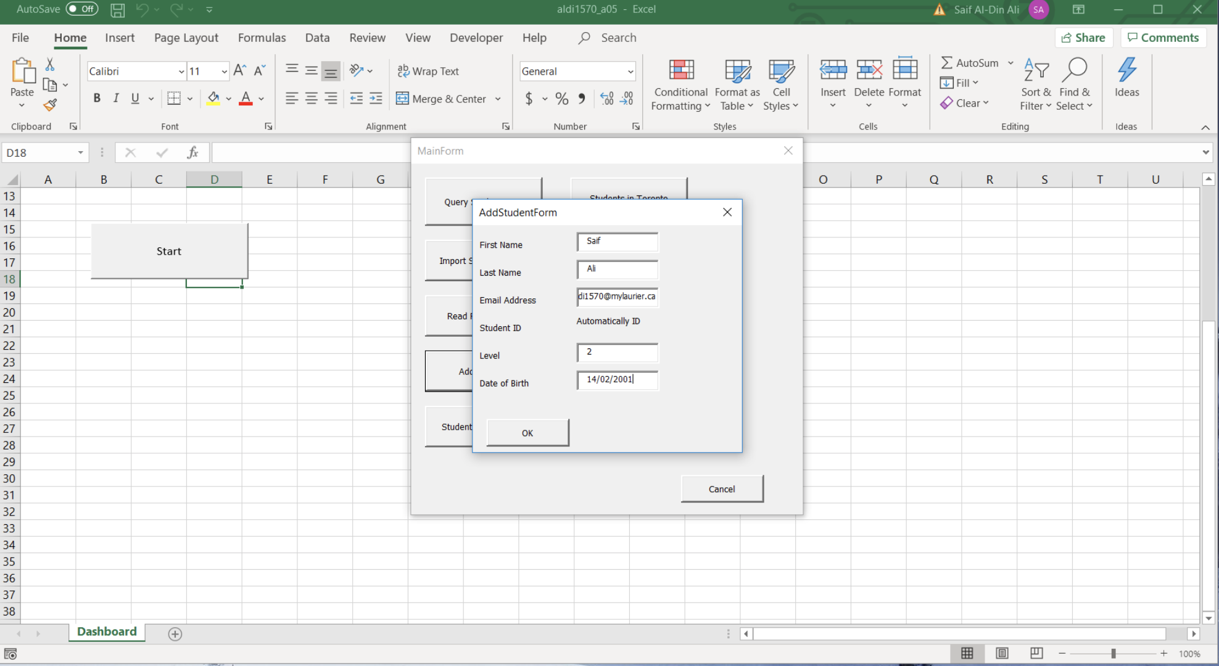

After closing the dashboard the user will see a new worksheet called ‘New Students’ that presents the data they just added.

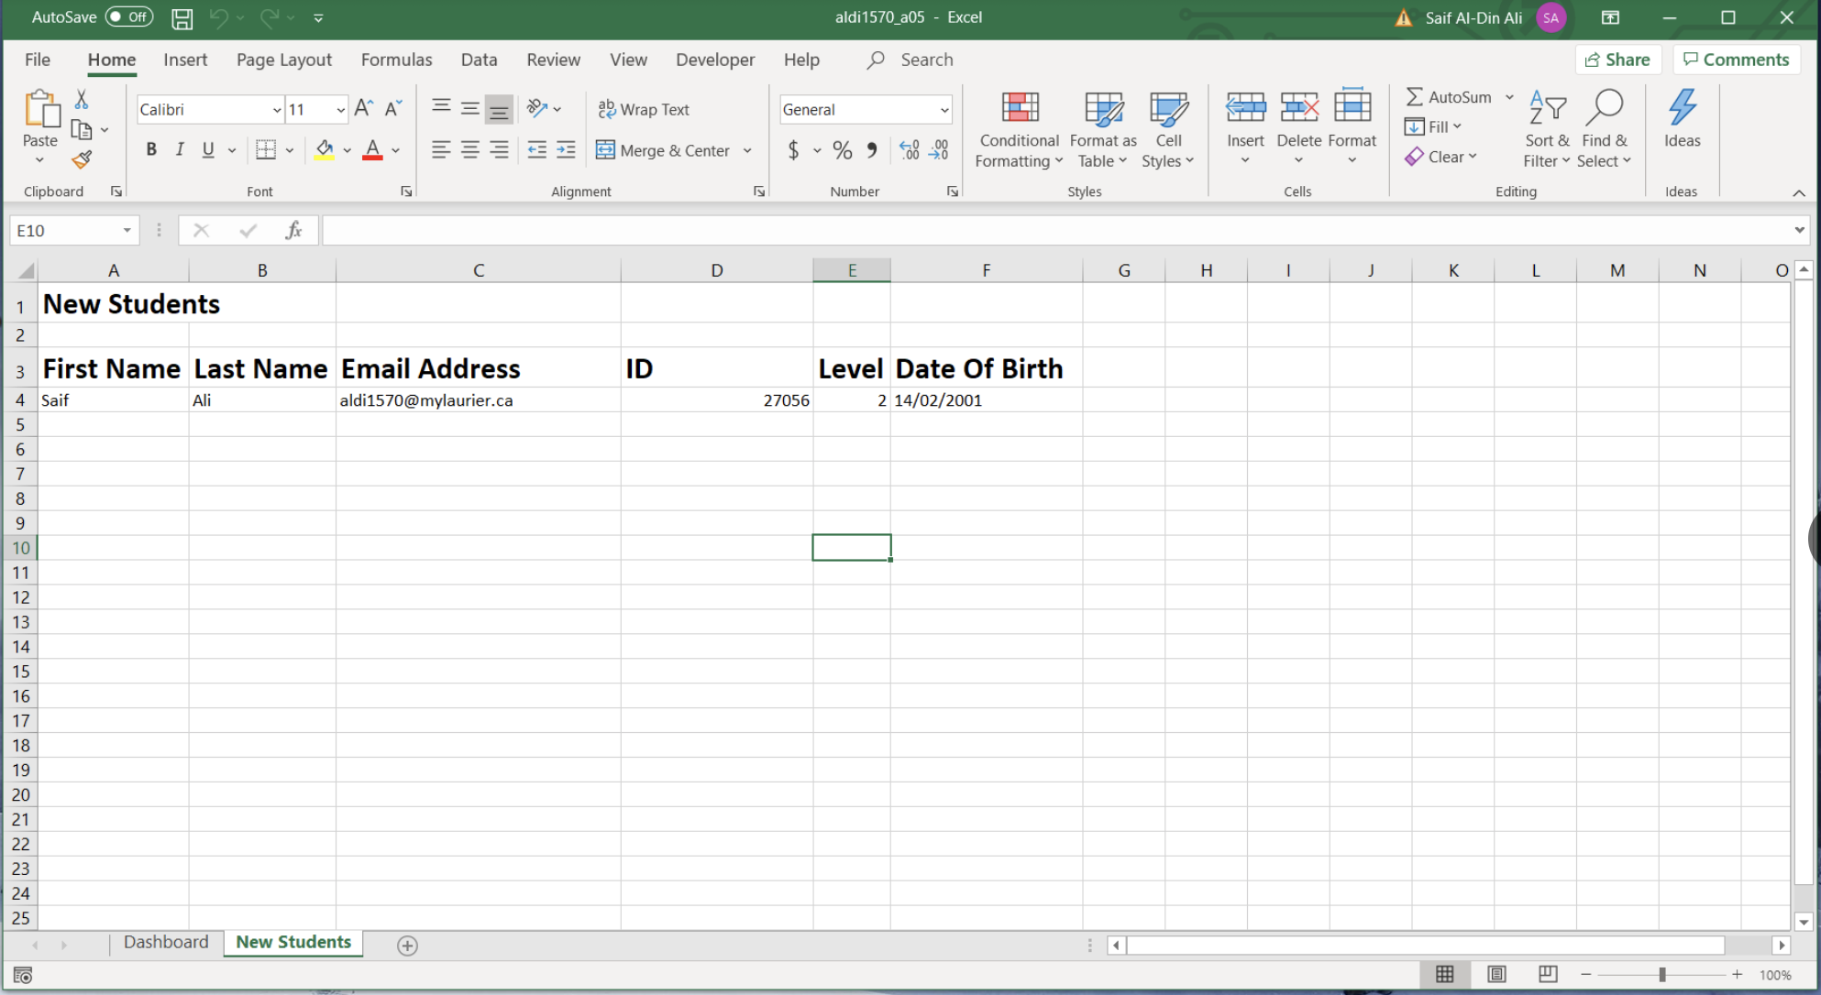

If the user adds a new user it will be displayed below the existing users on the worksheet.

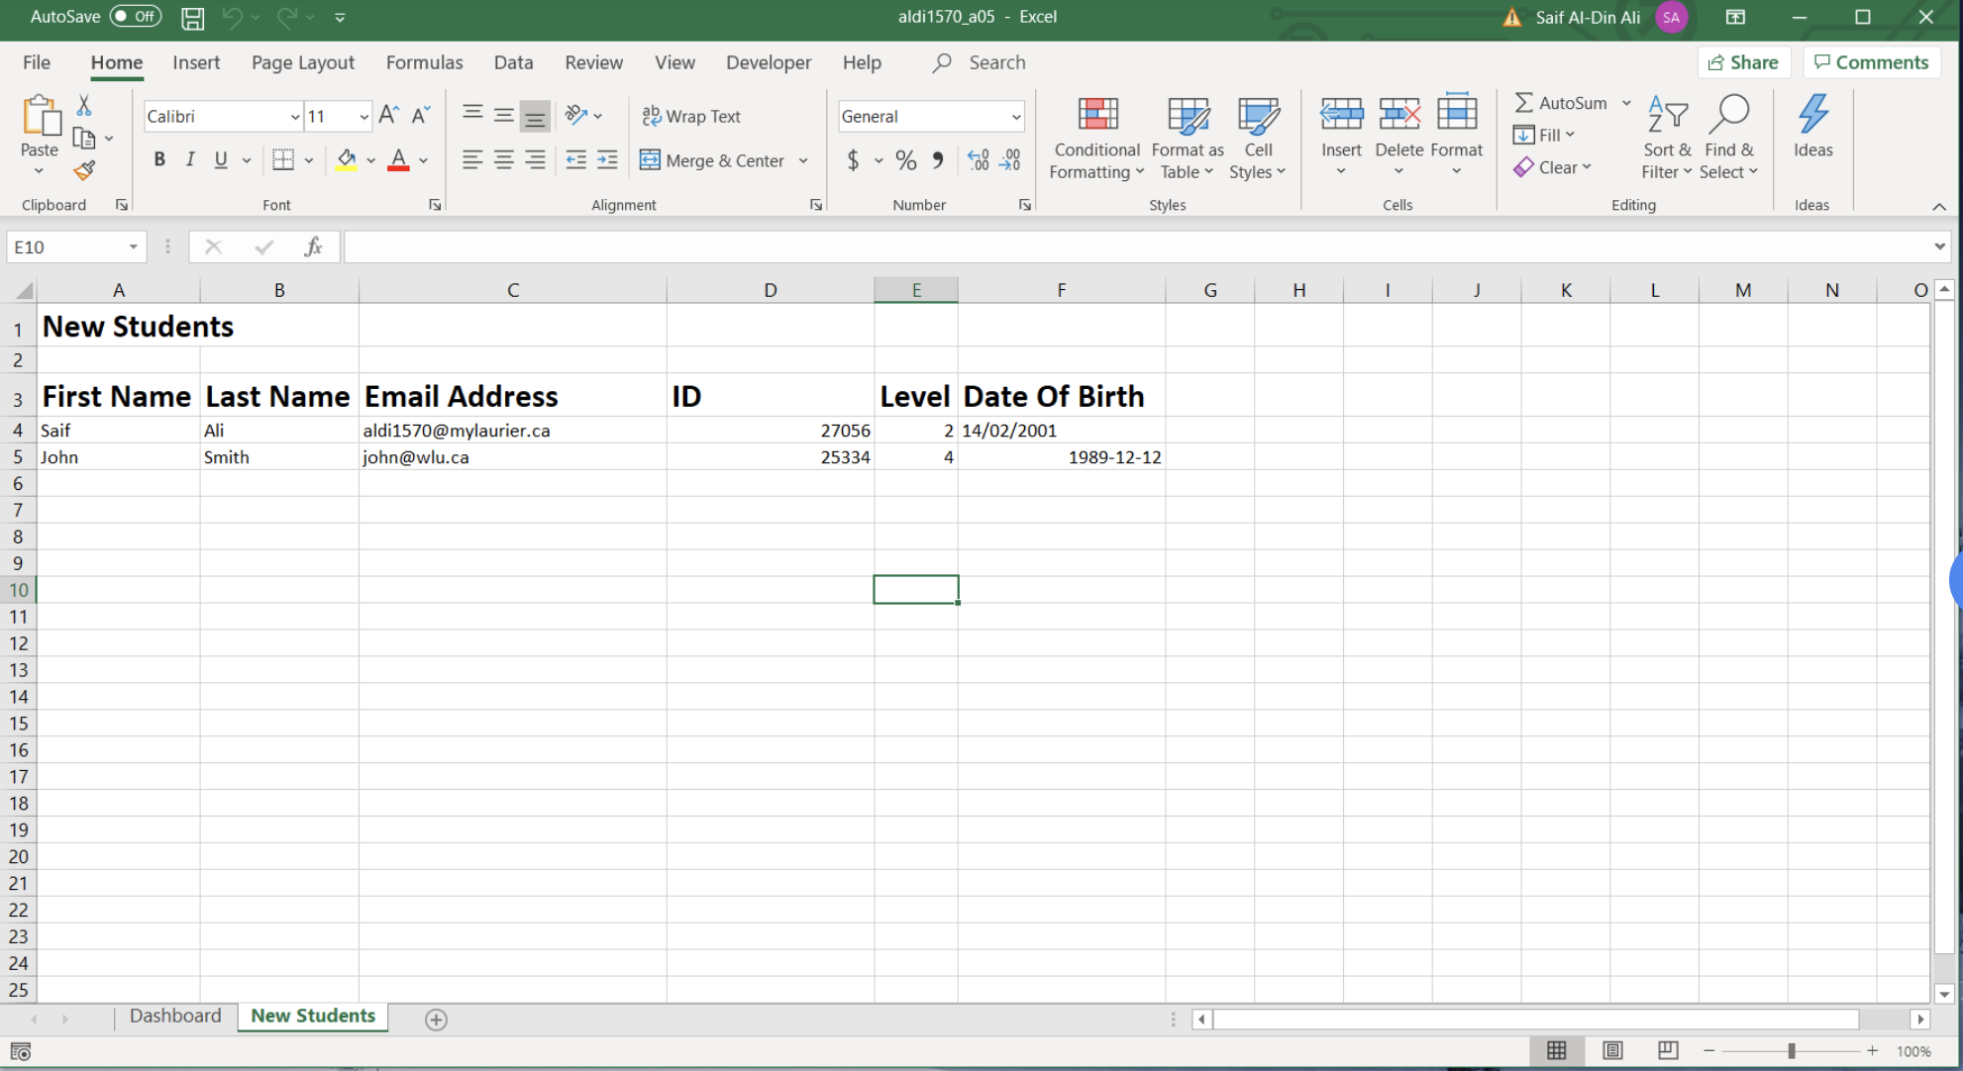

**G)** The fifth button ‘Students in Waterloo’ will query the Access database and retrieve the full name and address of all students currently living in Waterloo.

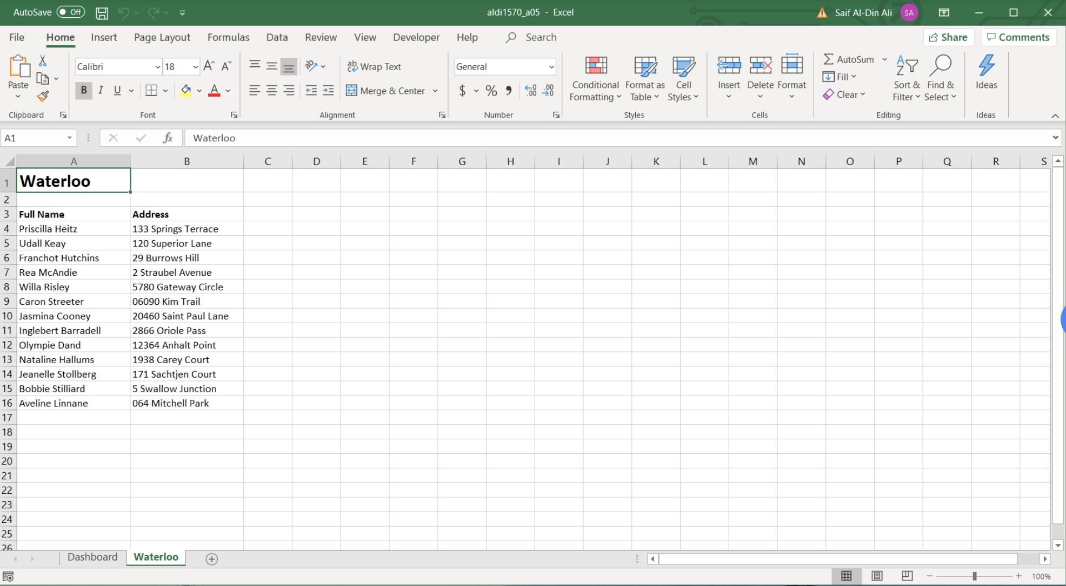

**H)** The sixth button ‘Students in Toronto’ will query the Access database and get the number of students that live in Toronto. It will then display that number in a message box.

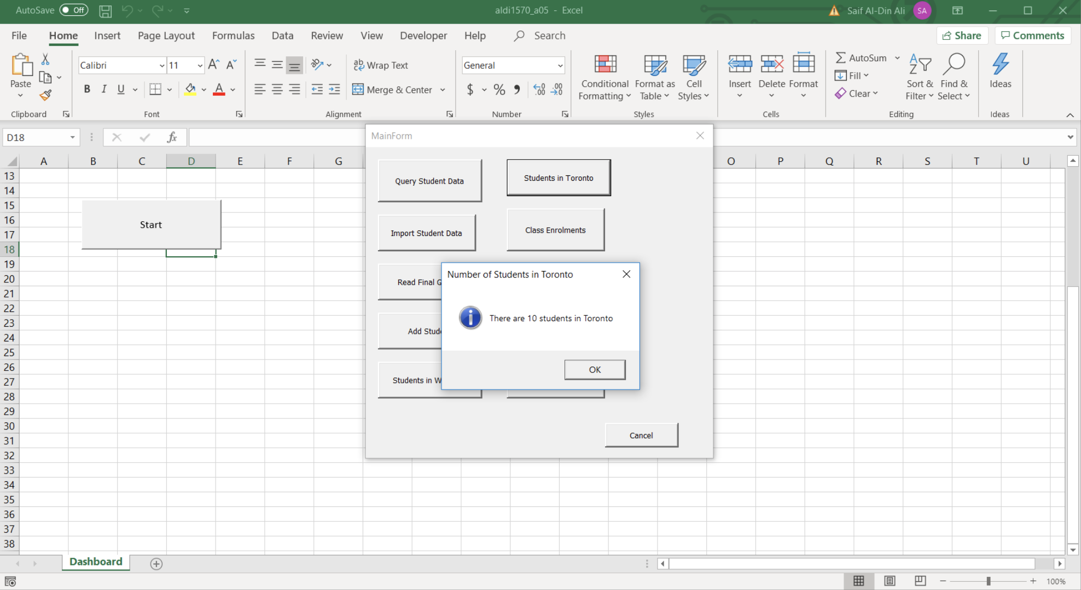

**I)** The seventh button ‘Course Enrolments’ will first present the user with a userform where they can select the course title and term from a listbox.

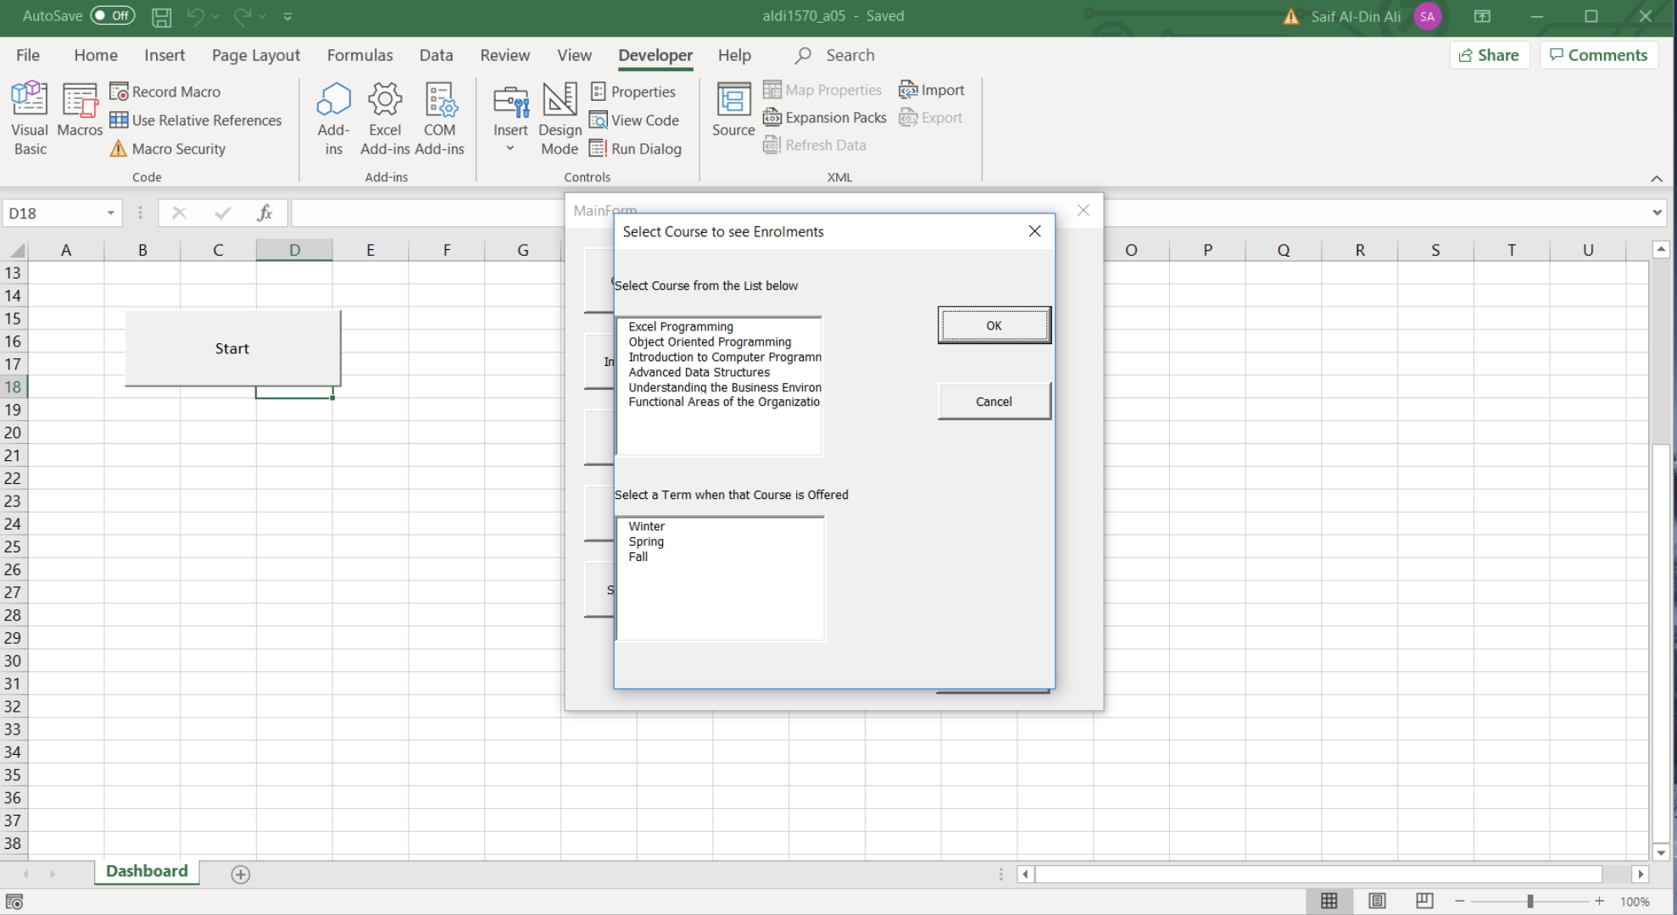

Based on the selected course the application will retrieve the associated CRN with the course and get the Course Code and number of students that are enrolled in that course. If the Enrolemnts table is empty then that means that no data has been written to the database and dialog box will appear allowing the user to select the enrolments.dat file. If the Enrolments table is already populated then that means that the user has already written data from enrolments.dat to the database and there will be no need to rewrite the data again, so no dialog box will appear. The final result will be displayed in a new worksheet called ‘Course Enrolments’ with the data displayed accordingly.

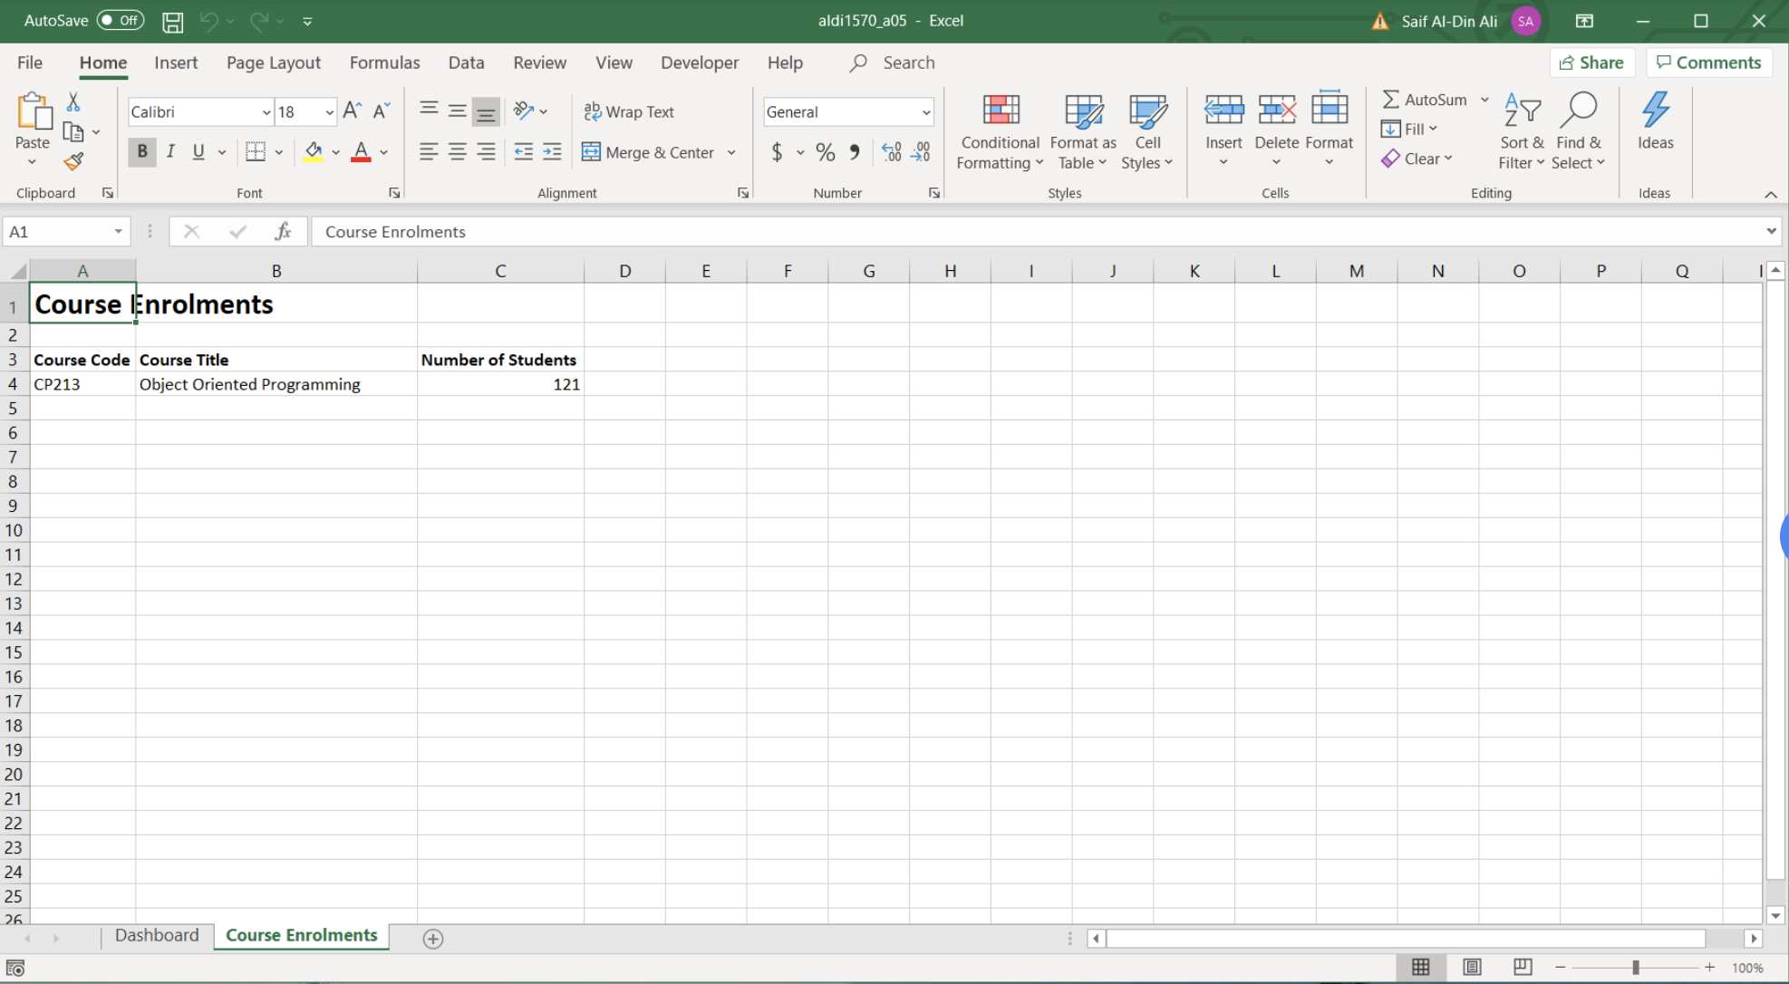

**J)** The eighth button ‘Failed Students’ will display a userform where the user can select a course and term that will be used to query data from the database.

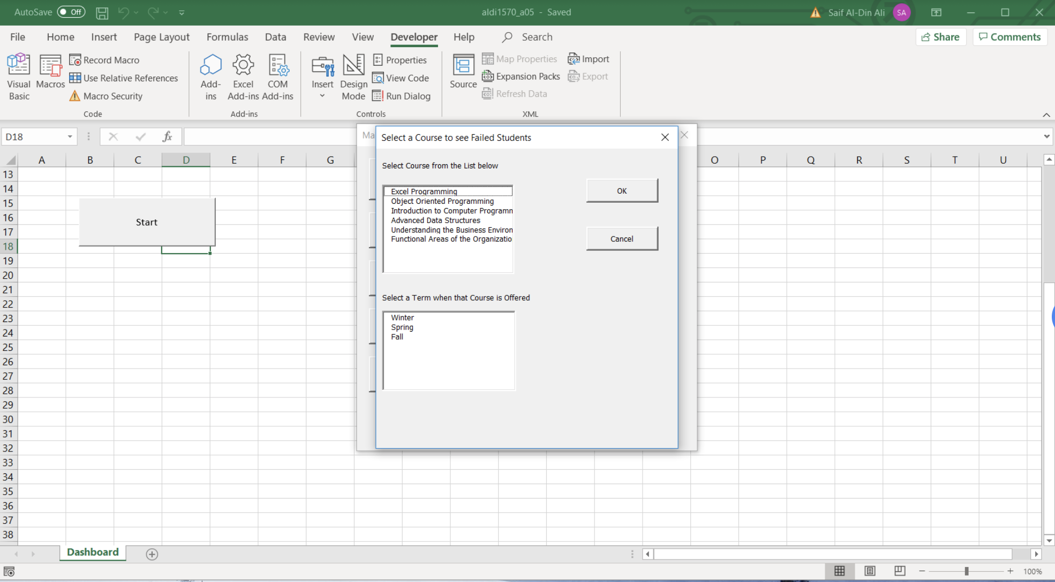

Based on the selected course the application will retrieve the associated CRN with the course and get information about students with a grade less than 50 in that course. If the Grades table is empty then that means that no data has been written to the database and dialog box will appear allowing the user to select the finalgrades.dat file. If the Grades table is already populated then that means that the user has already written data from finalgrades.dat to the database and there will be no need to rewrite the data again, so no dialog box will appear. The final result will be displayed in a new worksheet called ‘Course Failures with the data displayed accordingly.

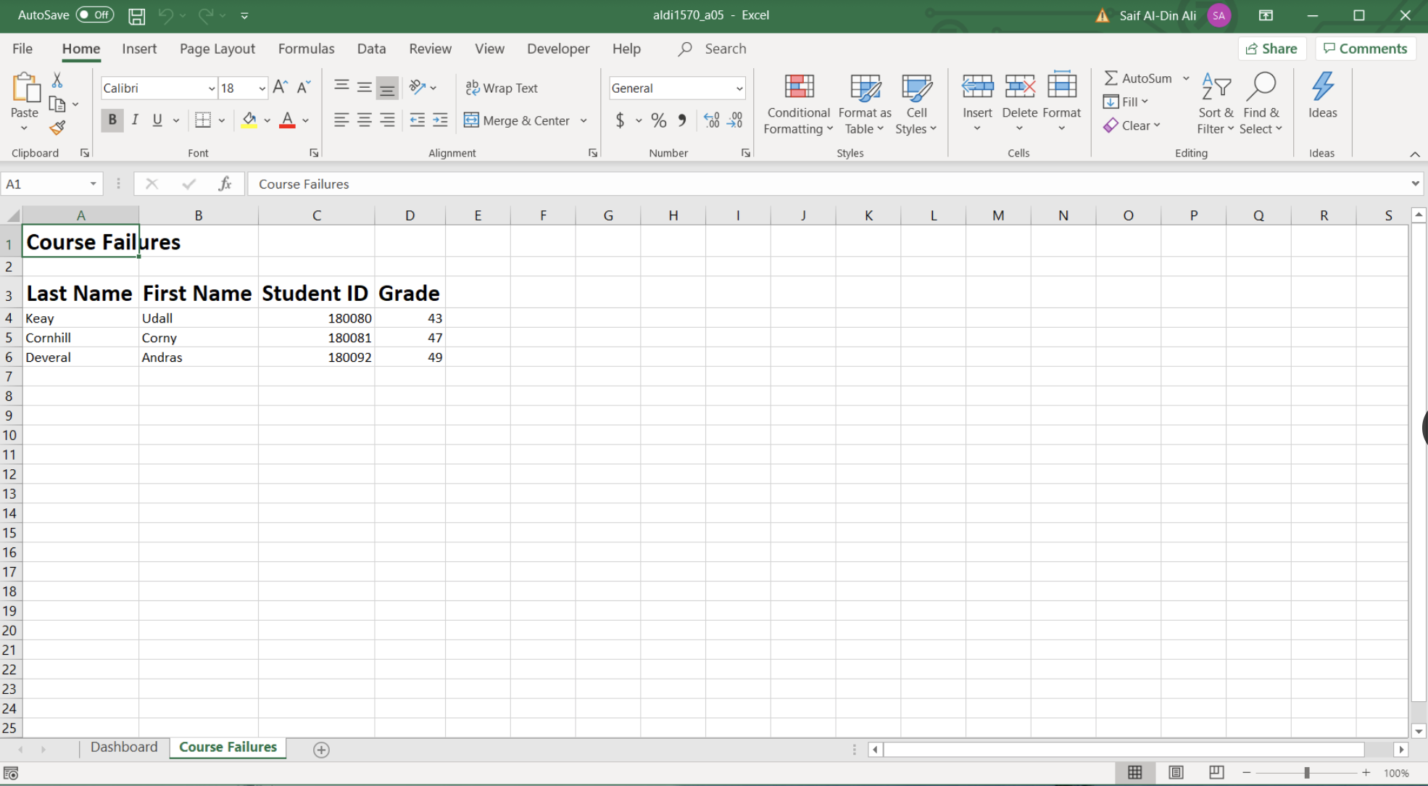

**K)** The ninth button ‘Students from St. Jacobs' will query the Access database and get the number of students that live in St. Jacobs. It will then display that number in a message box.

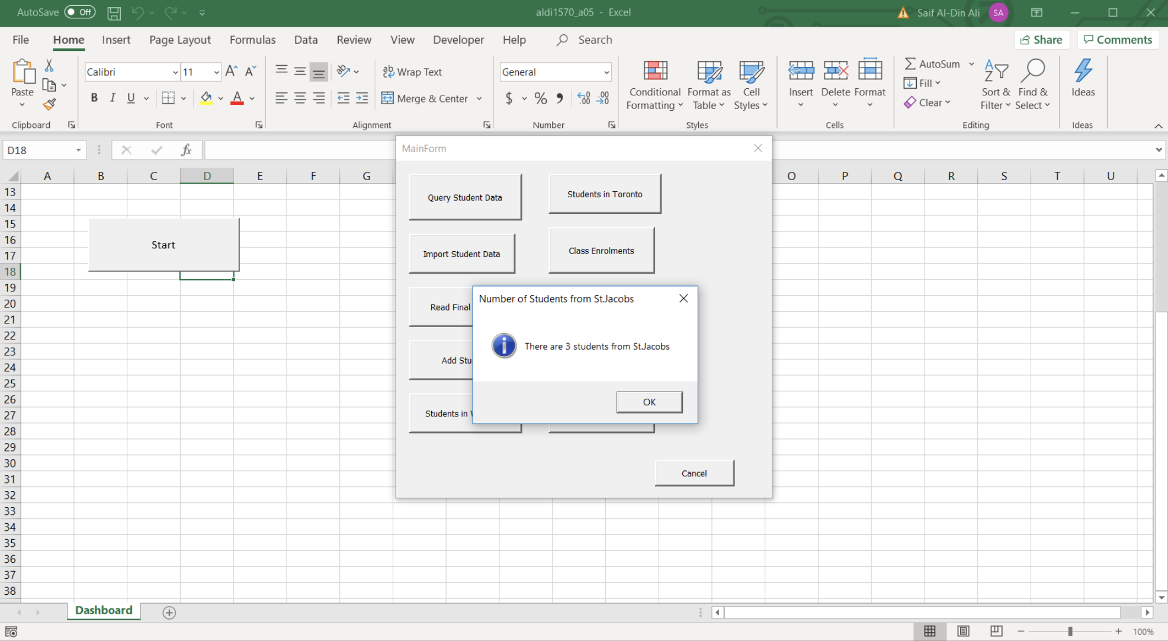

**L)** The tenth and final button is called ‘Grades Report(.docx)’. This button will start off by displaying a userform where the user can select a course title and term that will be used to query data from the database.

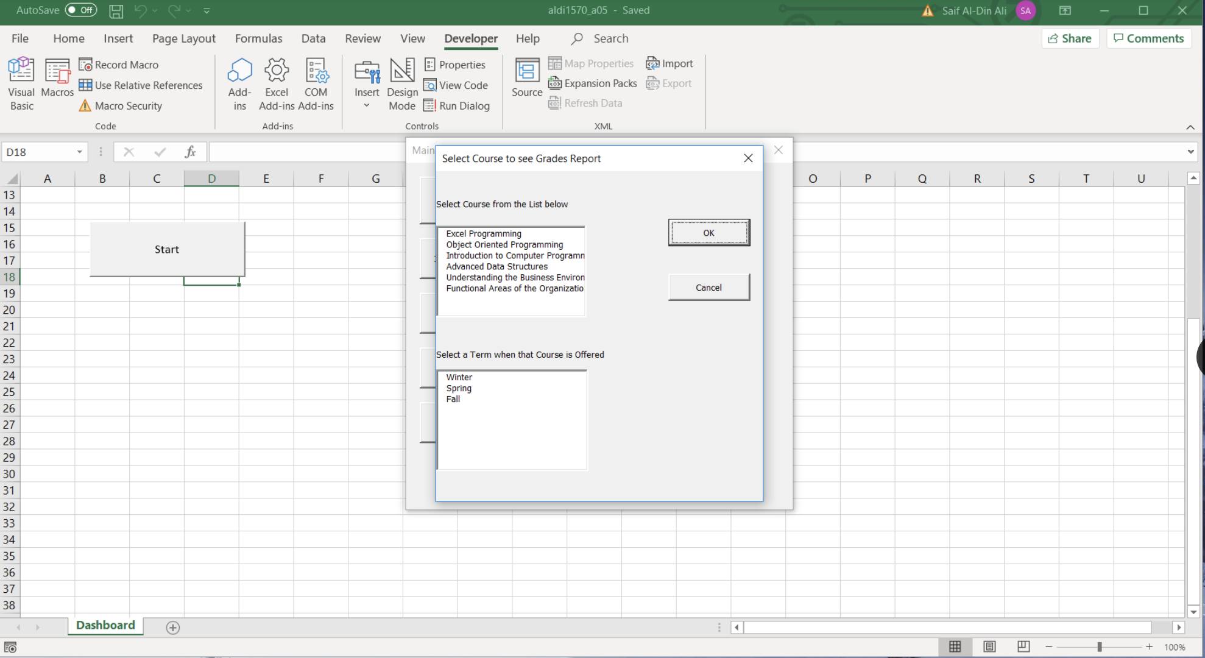

The application will get the grades of all students who took that course at that term and display the class grades in a histogram chart. The chart will be first displayed in a new worksheet called ‘Histogram Chart’. On that worksheet as well the bins and frequencies associated with that course will be visible to the user as ranges.

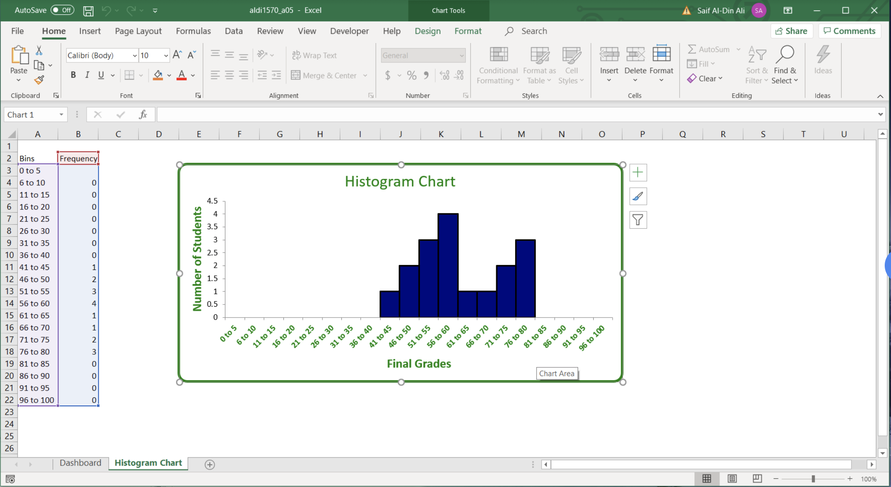

As well as create a new histogram chart the application will create a new Word (.docx) document that will contain relevant information. Firstly, the document will have the title ‘Grades Report’, it will then display the name and term of the course. After that, the application will display a list of the full names of all students that took that course at that time as well as the grade they got. Furthermore, the document will display the mean, median, mode and standard deviation of the class. Then the chart will copy the histogram chart generated and paste it into the document. Finally the class average will be included at the bottom of the report.

